InteriAR

**Project Proposal**

**Group H**

Cleon Grant

Ethan Newell

Tanzum Begum

Jibril Omar Ali

Ifrah Shahid

Liban Farah

Shah Ali

Project supervisor: Frederic Fol Leymarie

Goldsmiths College, University of London

Course code: IS52018C

Software Projects

15/12/2017

## Table of Contents

User Need Overview & Concept Introduction 3

Data gathering and requirements 3

Functional Specification 4

Ethical Audit 4

Privacy and data protection 4

Intellectual property 4

Design 5

Prototyping 6

Conceptual prototyping 6

Functional prototyping 7

Wall colouring 7

Augmented Reality Objects 8

Database 8

Technical Architecture 9

Database 9

Augmented Reality Implementation 9

Messaging 10

Payment 10

Evaluation Plan 10

Project Management 11

Conclusion 11

Bibliography 12

Appendices 13

Data gathering and requirements 13

Functional Specification 18

Design 19

Prototyping 22

Project management 22

## 

## User Need Overview & Concept Introduction

InteriAR is an innovative way of providing home owners inspiration on the go. Our application will help users design their dream room; combining augmented reality techniques with carefully selected decorators that can make their augmentation a reality.  Users will be able to choose 3D models of furniture and place it in their living space, complementing their existing layout to explore new designs. InteriAR takes it a step further by allowing its users to also change the colour of their walls to really get the full picture.

## Data gathering and requirements

We identified many potential stakeholders after conducting both extensive market research and approaching companies and the general public and outlined them in a diagram [Appendix A]. The primary stakeholders we identified were users who want an easier way to visualize a space before investing financially into decorating. At InteriAR we offer them a way to envision their project in great detail, avoiding these potential risks.  Furthermore, of the prospective users we asked ‘does this idea appeal to you? ’ 60.9% of respondents said yes (APPCOMBINE), and of those who answered ‘yes’, over 50% were in the age group 26-45 (APPCOMBINE). This survey derived the users who fitted into that age range as major stakeholders as they were also more likely to be homeowners or long term renters. [1] We created two user personas to showcase our general findings. [Appendix B, C] We gathered more data among users involving functions of the app, analysing the data showed 82.6% of users found the 3D viewing of the furniture to be the most appealing aspect of the application (APPCOMBINE). This meant that that we listed 3D functionality of the application as a project requirement.

Another group of significant stakeholders we identified were retailers of furniture. Retailers want the data on the trends of the industry; for instance what pieces of furniture customers mostly use within the app, and which designs are liked the most. This would enable them to produce the type of furniture wanted by the public and keep a closer eye on industry patterns. We concluded that IKEA, being one of the world’s largest furniture producers with a market share of 8.2% in the UK in 2016 [2], was also a potential stakeholder. This gave rise to the idea that we would use IKEA’s furniture database within our application to allow users to design their home using their extensive furniture catalogue.

The final group of major stakeholders which were identified were decorating companies. We gathered data among decorators in the London region; two of the main questions posed were if they would like to see an app such as this and if they would contribute financially to use this service which enables them to find customers efficiently. 90% of respondents said would like to see such an application’ and 72% said that they ‘pay a percentage of job fees for the matching service’ [APPENDIX].  Analysing the data gathered from this vital survey showed that decorators are major stakeholders in the application and therefore we created a decorator persona also. [Appendix F]

The primary computational problems we will encounter include the following:

* Accurately projecting 3D objects into an augmented reality space.
* Coding the ability to virtually paint walls which will include image segmentation, colour distance calculating and more.

An explanation of the above with details can be found in the appendix. [Appendix E, F]

## Functional Specification

InteriAR would have all users log in using an external API, eliminating the need for us to store sensitive data such as passwords. From that we will have a collection of decorators in a database that will hold reviews, location, and optionally a portfolio of past work. For the users we will store: user names, snapshots of designs, current orders and more.

We will utilise AR libraries combined with computer vision techniques to correctly project the orientation and position of 3D objects in an augmented space. Various image segmentation algorithms will aid in changing the colour of walls within the app. The user would potentially have to make changes to assist the projection and to input additional data. Once the user has chosen and finalised a design, they will be connected with decorators in our database over a long range wireless network. Their profiles will be displayed by area to the user who can contact them directly with our in-app messaging system.

The messaging system will likely be using pre-existing libraries as a starting point, as it won’t require much unique functionality. Once the decorator accepts the design sent to them and a quote is agreed, an escrow payment system will be shown. This will also include existing API’s to aid in the structure of the payment system.

We will also have an agreement which users will abide to, stating that the money will be released once the job has been completed. Once the completed job has been confirmed, the user will have the option of reviewing the decorator and allowing them to use the captured augmentation on their profile to help them build up their reputation.

The above procedures can be shown through the functional architecture diagram shown in the appendix. [Appendix ??]

## Ethical Audit

### Privacy and data protection

Customer privacy and data protection is vital to maintaining an ethical project. We will be adhering to the Data Protection Act 1998 [3] and any new laws coming into place. [4] We acknowledge our role as both the data controller and processor. The primary way we will deal with this responsibility will be to minimise the sensitive data we store and process. One method for achieving this will be using an external authentication API for user login so we don’t have to store passwords.  We will also make all public sharing of design snapshots strictly opt-in.

### Intellectual property

We can confirm that we are and will continue to adhere to all licensing on any software and assets we utilise. For example, our database of objects for an initial version is free to use providing we cite their paper. [5] For the software development kits, we will be using non-commercial or educational licenses, which would need to be updated should this project ever launch commercially.

We confirm that we will not be working with nor providing our app to children or vulnerable adults.

## Design

Try mention use case diagram [Appendix I?]

We have laid out the structure of our app using UML diagrams. One of which is the sequence diagram [Appendix H] that displays the user and system interactions under normal circumstances. In the case of the activity diagram [Appendix J], potential events that may occur have been shown and assigned follow up actions.

Our users will primarily interact with the app firstly by dragging and dropping 3D objects (e.g. furniture, pictures, carpets etc.) into a virtual space superimposing the camera feed. After snapshots of the design have been taken, users will be able to select decorators based on some criteria and communicate with them through instant messaging so that feasibility, price and further details can be established.

The customer however, is not the only user of the app. One of the main features that separates the app from its competitors is the inclusion of another stakeholder, the decorators. The profile for decorators would be more elaborate than that of the customer as it is used to sell themselves. As a result of this it would include other features such as the reviews that they have received thus far through the app, a portfolio of their previous projects, as well as their qualifications. All of which are vital to persuade the customer to select them, which is especially important for the decorators that are freelancing as they are a stakeholder that can potentially make a viable revenue stream that they may not find outside of the app.

INCLUDE STATEMENTS OF INTEREST THURSDAY  D O N T   F O R G E T ************************** [Appendix K]

## Prototyping

### Conceptual prototyping

For our conceptual prototype, we made a preliminary layout/wireframe of our app. [Appendix L] We created a low fidelity prototype using MarvelApp [6] which outlines the steps that the users would follow throughout the app.

Upon completing the conceptual prototype, we constructed a survey to gain an insight into user opinion. [Appendix M] This feedback was vital, as we gained a greater understanding on the preferences of our users, causing us to rethink and adapt our prototype.

Below are all the changes we made based on the user feedback:

* The budget filter was pointed out by a decorator as unfeasible due to most decorators not charging fixed prices for their service.
* Added the options of logging in via Google and Facebook. It was gathered that it may be tedious to create a new account and password for a new app. We have adjusted our design by replacing this option with popular authentication methods. This also allows us to avoid storing and becoming directly responsible for user passwords.
* Changed the camera screen orientation to landscape.
* Added an FAQ section to the help screen.

### Functional prototyping

The functional prototyping for InteriAR consisted of three main technical questions:

* Is virtual wall colouring feasible to implement and what is the best method of doing so?
* Is “marked tracking” a viable method of us displaying and moving 3D objects in our augmented reality space?
* Will MongoDB be able to handle the volume of users and transactions the app may need in future?

#### Wall colouring

#### 

This prototype was created on Processing 3[7] using the Ketai for Android library [8] to access the camera on a mobile device. The software allows a user to tap a pixel on the live video, grabbing the RGB values from it. It then analyses every pixel on the camera feed and calculates whether they are similar enough to the grabbed colour. If they are, the pixel is repainted in red.

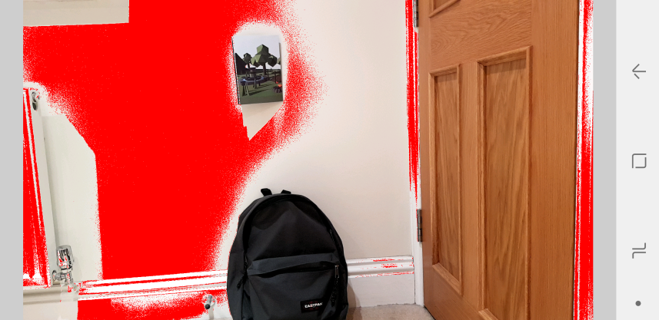

Figure 1. InteriAR wall colouring functional prototype v1

The prototype manages to successfully detect part of the surrounding wall, as well as avoid the more obviously differently coloured obstacles; however, it also misses out large portions and does pick up some unwanted additions. Another factor is performance; when calculating colour distance on each pixel in the feed, especially on a mobile-phone processor, the program starts to stutter.

What we have learned from this prototype:

* It is feasible to implement. Even on a very basic level this functioned in some capacity.
* Further research must be done into colour matching for improved accuracy.
* We need to look into improving the performance drastically, whether via grouping pixels together or relying on another method of detection such as image segmentation.

Research into software utilising similar features can be seen in the appendix. [Appendix N]

#### Augmented Reality Objects

#### 

This prototype was created on Unity3D [9] using the Vuforia AR library. [10] The software utilises a database of markers which are images of real objects or surfaces with enough unique features to be distinguishable from the surrounding area. Computer generated 3D objects are then assigned a marker so that when the camera detects it, the object will superimposed upon it wherever it moves.

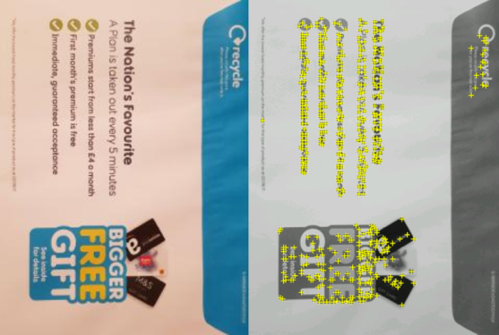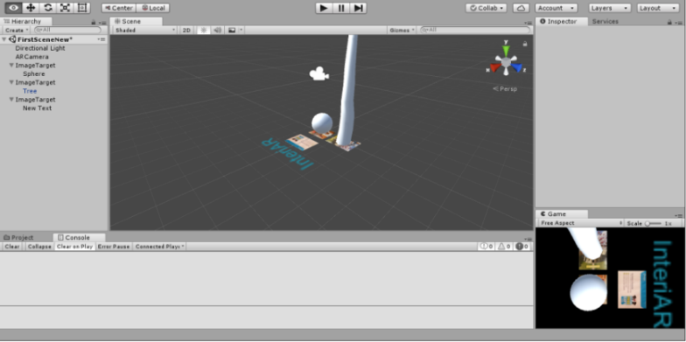

Figure 2. InteriAR objects prototype v1 in Unity                                 Figure 3. Marker with “features” highlighted

The close up functionality is impressive, even when dealing with inconsistent lighting. However as soon as the range increases past 2-3 meters it quickly becomes incapable of consistently tracking the markers.

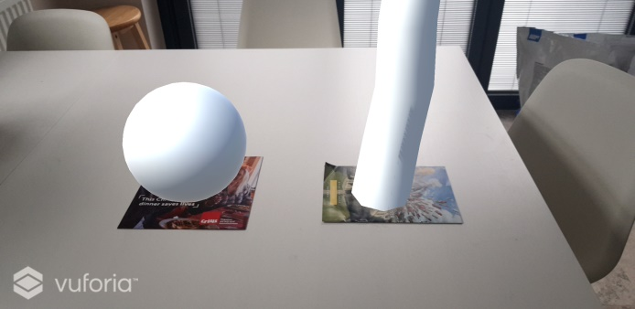

What we have learned from this prototype:

* Recognition based tracking is only viable at close range.
* While very basic, this software ran seamlessly on mobile.
* It may still be useful for some elements of our project, but we need to research further into projection based AR.

Figure 4. InteriAR objects prototype v1 utilising Vuforia

#### Database

To assess the feasibility of using MongoDB [11] for our project we implemented a cloud-based database using mLab services. [12] We wanted to test if the cloud-based service was capable of handling high quantities of data being thrown at it and updated via Pymongo scripts. [13]

To do this, we used python to insert 1,000,000 user documents into a collection and ran find commands to grab out users based on field properties. Both the insertion and any interactive find/update script I ran functioned smoothly and in a timely manner.

What we have learned from this prototype:

* We can efficiently add users to our database using python scripts.
* We can update, remove and pull information from the documents on the database in real-time.

## Technical Architecture

### Database

#### 

As we won’t be using our own database to be validating and logging users in, we have come to the conclusion of using Facebook and Google’s OAuth API [14][15][16] to help create accounts. The reason is due to the feedback we got from potential users who said they are happy to or even prefer to log in with Facebook or Google. Even though this implementation may exclude people without the above services, it makes the whole process of signing up to the app more efficient. It also solves some issues we may have encrypting and protecting the data correctly as passwords won’t be stored with us.

After conducting research, we have chosen to use MongoDB based on the efficiency and our familiarity with JavaScript Object Notation. [17]

### Augmented Reality Implementation

The main selling point of InteriAR, is the augmented reality. We aim to allow users to visualise a whole room within their phone. To develop this, we have decided to use Unity3D. Unity is designed for, but not restricted to, 3D games. As Unity is an excellent 3D engine that can be applied outside of game development, it seems to be the perfect software to use. Another positive is that it can easily be deployed to Android and IOS. As an alternative, we looked at using Android Studio. [18] We opted for Unity primarily because every augmented object will be a 3D model and Android Studio doesn’t natively support 3D modelling and design.

Whilst deciding which type of device to focus our implementation on, we initially thought that tablets were the ideal machine for our concept. Although tablets would be ideal due to more favourable screen sizes, feedback from potential users [Appendix ?] suggests that limiting deployment to tablets would severely impact our user-base. We excluded personal computers from our options due to the need for an easily portable external, or rear facing camera.

One feature of our Augmentation would be the ability to change the colour of walls and in later versions, even whole floors. We plan to achieve this by using a computer vision technique called K-Clustering, which is a form of image segmentation. [19][20] This would give meaning to different sections of an image that are separated by some common factor. Through prototyping, we have seen that simply taking the RGB value of pixels in an image has its problems, as pixels change colour due to multiple external factors.

For the actual technology behind the augmentation, we have decided to use an external Unity library called Wikitude. [21] We chose this over Vuforia (another Unity library for AR) as Vuforia is only good for recognition based AR. This is using track-able images as basis for projection such as a leaflet. Through prototyping we have discovered that this is not practical as we would like users to not need to use trackers to place things in their rooms, not to mention that if you’re too far from a tracker, the augmentation accuracy rapidly drops of. On the other hand, Wikitude uses a projection based augmentation called SLAM which we explain further in the appendix. [Appendix ?] Simultaneous Localisation and Mapping is the type of AR that we need as it recognises space and angles allowing it to correctly project the orientation of the 3D object. We also looked at ARCore (Android’s AR library) and ARKit (Apple’s AR library) however they only support their respective platforms. [22][23]

### Messaging

We aim to including instant messaging to allow customers and decorators to securely communicate with each other. We have chosen to use an instant messaging API over standard SMS as people may not be comfortable giving their numbers out. The API we will use is called SendBird [24]; it is free for small teams and will allow users to send picture messages. As picture messaging wasn’t free for most other APIs, if we have issues with SendBird, we will resort to making the chat from scratch.

### Payment

For the Payment within the app, we have decided to use PayPal as it supports standard card use even without a PayPal account. We aim to have an escrow system to hold the money until the job is done to avoid scams. In principle, this would be simple; however payments aren’t going directly to us. There is one available python library that can implement escrow called Balanced [25] however there are some issues with the documentation so further research needs to be conducted.

## Evaluation Plan

In order to validate all the decisions made during and after development, we will try to test as much as possible. This will include hardware devices of our target users, the event of the user suddenly being disconnected from the app and so on. This is to ensure the highest quality for our stakeholders, whilst maintaining the integrity of the app.

Below will outline the strategy that we will follow:

* Data Gathering regarding popular devices used among target audience
  + We will perform hardware tests, such as resolution, screen size and camera tests to make sure the app can run.
* We will then run installation tests
  + Test for installation errors by installing then uninstalling.
* Black Box Testing
  + Testing the interface and the usability of the app as a whole.
* White box Testing
  + We can observe core performance, memory usage and access speed during these tests. We also observe how the app handles sudden disconnection.
* Closed Beta Testing
  + A select few users will use the app and fill out a questionnaire asking core questions that we expect the app to achieve, with some open questions for improvement.

During the course of pre and post development, we will continuously evaluate the many different aspects of InteriAR.

## Project Management

The future development of this project will be focussed around splitting our resources up into smaller groups and giving them clear sub-tasks to meet as part of their overarching long-term milestones. This will be primarily managed via Trello [26] for sub-tasks and documented with a Gantt chart [Appendix O] based off a critical path diagram [Appendix P] and work break-down [Appendix Q] for the larger tasks and milestones.

For the software development there will be two group members focusing on the mobile application, working closely with another small group who will be focussed on the backend database. These parallel development projects will hold frequent meetings to ensure the other team is fully updated and both processes are on the same track. During development we will be sticking to a separation of concerns principle wherever possible to allow smoother modification where necessary.

The members not directly involved with coding will primarily be focused on making sure all documentation is up to date and fulfilling any necessary requirements for the final report. They will also semi-regularly attend the software-focused meetings to ensure everyone has full knowledge of the current status and any changes that have been made during development.

While not fully embracing a pure agile methodology; we will be adhering to some of the core principles. [27] The stand outs for our project will be “the most efficient and effective method of conveying information to and within a development team is face-to-face conversation” and to deliver working software frequently.

## Conclusion

To summarise, we are proposing to develop what we believe to be a genuinely unique and innovative idea. While the individual components of our project may currently exist, there is nothing with the full package of complimenting features we aim to provide. These features have been chosen based on both user-needs gathered from market research and our drive to overcome computational challenges.

We will be implementing augmented reality, computer vision techniques, non-trivial databases and more; whilst maintaining intuitive user interaction and ethical data practices. To ensure feasibility of our concept, we conducted a range of conceptual and functional prototyping procedures, learning a lot in the process to take forwards.

Our team has a clear plan for implementing, testing and evaluating our project to ensure timely progress resulting an impressive product.

We firmly believe InteriAR is a concept worth realising.

## Bibliography

1. Barton C. Home ownership and renting: demographics [Internet]. Researchbriefings.parliament.uk. 2017 [cited 3 December 2017]. Available from: <http://researchbriefings.parliament.uk/ResearchBriefing/Summary/CBP-7706>
2. IKEA T, release P, results I. IKEA UK business results - IKEA [Internet]. Ikea.com. 2017 [cited 3 December 2017]. Available from: http://www.ikea.com/gb/en/this-is-ikea/newsroom/press-release/ikea-uk-business-results/
3. Data Protection Act 1998 [Internet]. Legislation.gov.uk. 1998 [cited 3 December 2017]. Available from: <https://www.legislation.gov.uk/ukpga/1998/29>
4. General Data Protection Regulation (GDPR) – Final text neatly arranged [Internet]. General Data Protection Regulation (GDPR). 2017 [cited 3 December 2017]. Available from: https://gdpr-info.eu/
5. J. Lim J, Pirsiavash H, Torralba A. Parsing IKEA Objects: Fine Pose Estimation. ICCV; 2013.
6. Marvel App - Free mobile & web prototyping (iOS, Android) for designers – Marvel [Internet]. Marvel Prototyping. 2017 [cited 6 November 2017]. Available from: <https://marvelapp.com/prototyping/>
7. Processing.org [Internet]. Processing.org. 2017 [cited 12 December 2017]. Available from: https://processing.org/
8. Ketai [Internet]. Ketai.org. 2017 [cited 21 November 2017]. Available from: <http://ketai.org/>
9. Unity software [Internet]. Unity3d. 2017 [cited 13 December 2017]. Available from: <https://unity3d.com/>
10. Vuforia | Augmented Reality [Internet]. Vuforia.com. 2017 [cited 29 November 2017]. Available from: <https://www.vuforia.com/>
11. MongoDB for GIANT Ideas [Internet]. MongoDB. 2017 [cited 11 December 2017]. Available from: <https://www.mongodb.com/>
12. MongoDB Hosting: Database-as-a-Service by mLab [Internet]. mLab. 2017 [cited 11 December 2017]. Available from: <https://mlab.com/>
13. pymongo 3.6.0 : Python Package Index [Internet]. Pypi.python.org. 2017 [cited 11 December 2017]. Available from: <https://pypi.python.org/pypi/pymongo>
14. Facebook Login - Documentation - Facebook for Developers [Internet]. Facebook for Developers. 2017 [cited 11 December 2017]. Available from: <https://developers.facebook.com/docs/facebook-login>
15. Google Identity Platform  |  Google Developers [Internet]. Google Developers. 2017 [cited 11 December 2017]. Available from: https://developers.google.com/identity/
16. OAuth 2.0 — OAuth [Internet]. Oauth.net. 2017 [cited 12 December 2017]. Available from: https://oauth.net/2/
17. Győrödi C, Gyorodi R, Pecherle G, Olah A. A Comparative Study: MongoDB vs. MySQL. University of Oradea; 2015.
18. Android Studio and SDK Tools | Android Studio [Internet]. Developer.android.com. 2017 [cited 12 December 2017]. Available from: <https://developer.android.com/studio/index.html>
19. Barghout L, Sheynin J. Real-world scene perception and perceptual organization: Lessons from Computer Vision. Journal of Vision. 2013;13(9):709-709.
20. Shapiro L, Stockman G. Computer vision. New Jersey, Upper Saddle River: Prentice Hall; 2001.
21. Wikitude Augmented Reality- The World's Leading Cross-Platform AR SDK [Internet]. Wikitude. 2017 [cited 11 December 2017]. Available from: <https://www.wikitude.com/>
22. ARCore - Google Developer  |  ARCore  |  Google Developers [Internet]. Google Developers. 2017 [cited 13 December 2017]. Available from: https://developers.google.com/ar/
23. ARKit - Apple Developer [Internet]. Developer.apple.com. 2017 [cited 13 December 2017]. Available from: https://developer.apple.com/arkit/
24. Messaging SDK and Chat API for Mobile Apps and Websites | SendBird [Internet]. SendBird. 2017 [cited 13 December 2017]. Available from: <http://sendbird.com>
25. balanced/balanced-python [Internet]. GitHub. 2017 [cited 11 December 2017]. Available from: <https://github.com/balanced/balanced-python>
26. Trello [Internet]. Trello.com. 2017 [cited 13 December 2017]. Available from: https://trello.com/
27. Martin R. Agile software development. Harlow, UK: Pearson; 2014.
28. Comport A, Marchand E, Pressigout M, Chaumette F. Real-time markerless tracking for augmented reality: the virtual visual servoing framework. IEEE Transactions on Visualization and Computer Graphics. 2006;12(4):615-628.
29. Klein G. Visual Tracking for Augmented Reality [Ph.D]. University of Cambridge; 2006.
30. P. Mountney, D. Stoyanov, A. Davison, and G.-Z. Yang, Simultaneous stereoscope localization and soft-tissue mapping for minimal invasive surgery, in Proc. Int’l Conf. Medical Image Computing and Computer Assisted Intervention (MICCAI), R. Larsen, M. Nielsen, and J. Sporring, eds., vol. 4190 of Lecture Notes in Computer Science, Springer-Verlag;2006

## Appendices

### Data gathering and requirements

1. Stakeholder diagram

The stakeholder diagram outlines the internal and external stakeholders of our concept

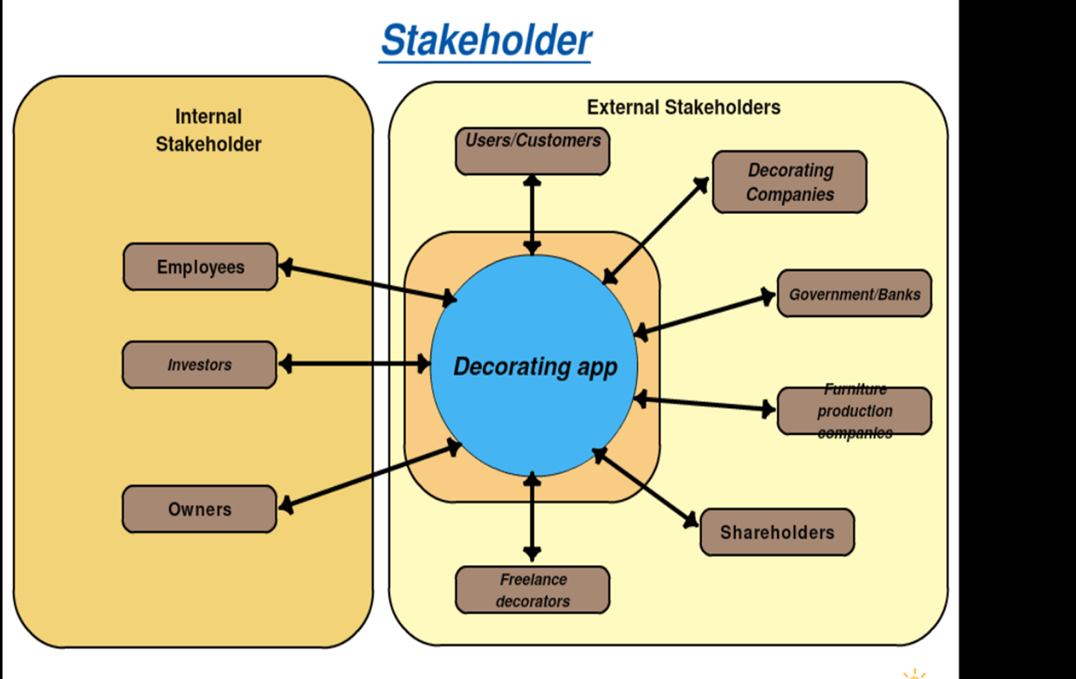

1. Persona 1

The personas outline a typical user of our app

|  |  |
| --- | --- |
| Persona: | InteriAR user persona |
| Photo: | https://www.womenshealth.gov/files/images/nwhw_30s-lady.jpg |
| Name: | Emily Campbell |
| Job title/major responsibilities: | Part time office administrator; temporarily quit full time work to care for her children. |
| Demographics: | * 31 years old * In a long term relationship * Physically able * Speaks English * Mother of 2 young children |
| Goals and tasks: | She is family oriented and takes great pride in her home, always looking to keep things fashionable and looking good.  One day she’d love to design her own home from scratch but isn’t yet in the financial position to do so.  Her daily tasks consist of caring for her children as well as part-time database upkeep in an insurance company. |
| Environment: | Emily owns a smart phone, current gen tablet and a family laptop. She considers herself relatively capable of using them all although she couldn’t tell you what SSD stands for or how much RAM she’s got.  She regularly browses the internet (connected via fibre home-broadband) and uses apps on her devices for both her and her children. |
| Quote: | “I know what I like, and how I like it.” |

1. Persona 2

Another example of a potential user

|  |  |
| --- | --- |
| Persona: | InteriAR user persona |
| Photo: | https://edc2.healthtap.com/ht-staging/user_answer/reference_image/6096/large/Testicular_Cancer.jpeg?1386670792 |
| Fictional name: | Dave Taylor |
| Job title/major responsibilities: | Full time newspaper columnist. |
| Demographics: | * 35 years old * Single * Requires a wheel-chair * Speaks English * No children |
| Goals and tasks: | Having recently bought his own flat for the first time, though it only has a couple of rooms he wants to make it really his. While he isn’t one for elaborate or fancy designs, he wants control of every detail and needs to know how it’ll look before committing.  His daily tasks are primarily writing and researching, both from the office and at home. |
| Environment: | Dave owns a large Note smartphone, no tablet and utilises a work laptop for several hours a day. He considers himself intermediate to advanced internet user and has broadband at home. |
| Quote: | “It’s my way or the highway.” |

1. Persona 3

A persona outlining the other side of the user-base, decorators.

|  |  |
| --- | --- |
| Persona: | InteriAR decorator persona |
| Photo: | http://www.absolutedecorating.com/wp-content/uploads/2016/01/professional-painter-and-decorator.jpg |
| Name: | Jeremy Trotter |
| Job title/major responsibilities: | Full time painter-decorator; team manager on larger projects. |
| Demographics: | * 42 years old * Married * Speaks English * Father of 2 teenage children * Physically active and able * Level 3 City & Guilds in painting and decorating * CHAS certified |
| Goals and tasks: | He loves his job and is adamant about maintaining a high quality finish in all his work. His goal is to help people bring their creative ideas and designs to life with his technical ability.  He spends time at work primarily out of office; painting and decorating, project managing, and training less senior decorators. |
| Environment: | Jeremy has a smartphone he’s competent with and is confident on the computers at the company office. He has a business line internet connection at work and ADSL-broadband at home. He primarily uses e-mail and SMS for communication. |
| Quote: | “If you want something done right, I’m your man. No job too big or small.” |

1. J

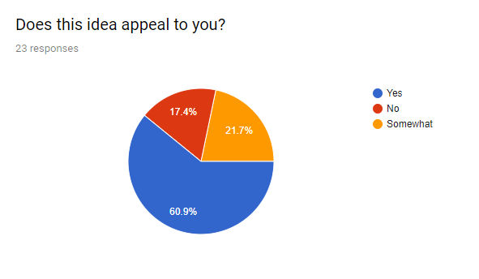

1. Accurately projecting 3D objects into an augmented reality space.

The issue in projecting objects into reality is firstly how to display the object. Augmented reality uses overlapping techniques to give the illusion that something virtual is occupying a real space. This starts off as images being placed over a live camera feed, however this ruins the illusion as small movements quickly reveal the fact that it’s just an image and nothing more. To get around this, several techniques are implemented to continue the illusion such as overlaying the camera with a virtual space, so when you place the object, you actually place it in a 3D space, which you can move around. This allows you to be able to correctly capture camera angles of a 3D object. This virtual space will attempt to match the angle and depth of your reality.

We explored several types of AR, and boiled it down to two. Projection based [REF] and recognition based [REF].

1. Coding the ability to virtually paint walls which will include image segmentation, colour distance calculating and more.

As this is an uncommon computation problem, there aren’t many code extracts we could use to aid us. However, we have managed to gather a lot of the computer vision topics we would need to be able to colour walls in virtually. Firstly, we would have to find a way to separate what is ‘wall’ and what isn’t. For this we would need image segmentation, a way of segmenting an image into like categories. From this, we can identify everything that’s similar, and apply an overlay where necessary. In this case, it would be a selected colour.  We could calculate colour distance to also pick out specific colours in the camera at one time and change or overlap them with another colour. The problem as per our functional prototype is that there are a lot of similar colours with an image, and colours constantly change throughout a camera’s feed. This causes the colouration to change as well as not cover the area correctly.

### Functional Specification

1. Functional Architecture Diagram

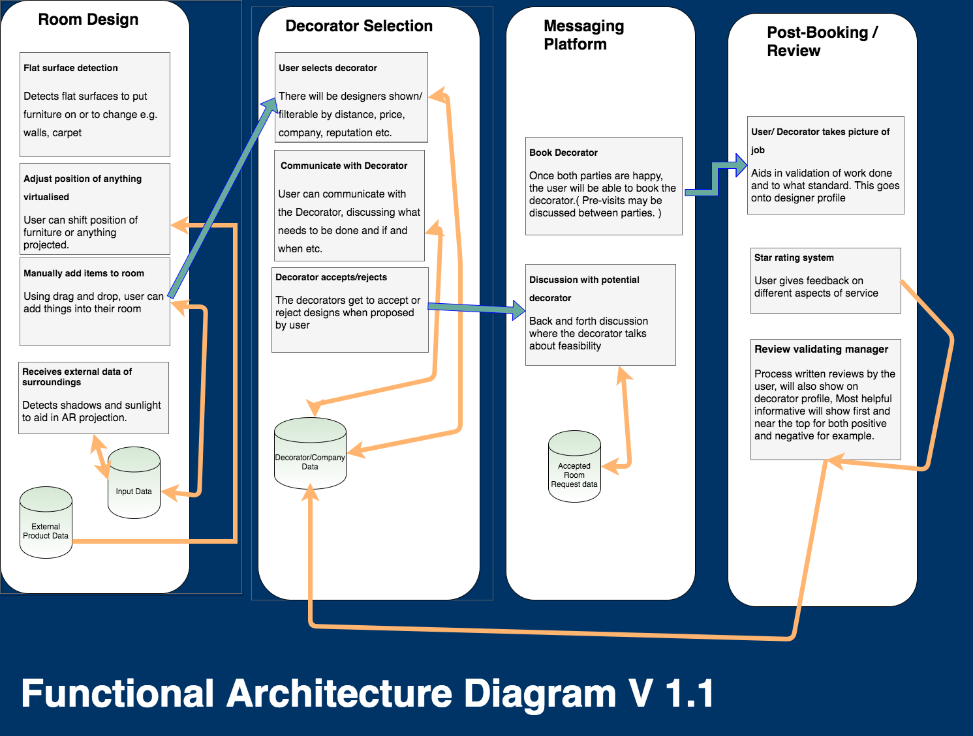

### Design

1. 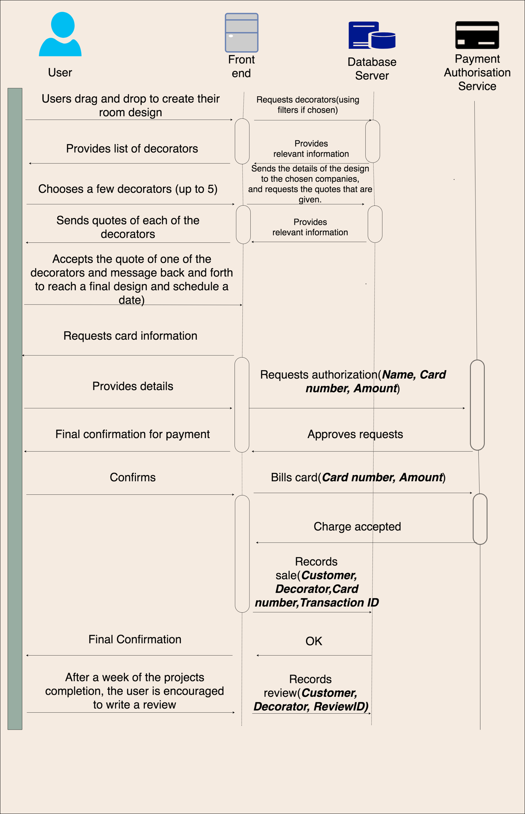Sequence Diagram
2. Use Case Diagram**NOT MENTIONED**

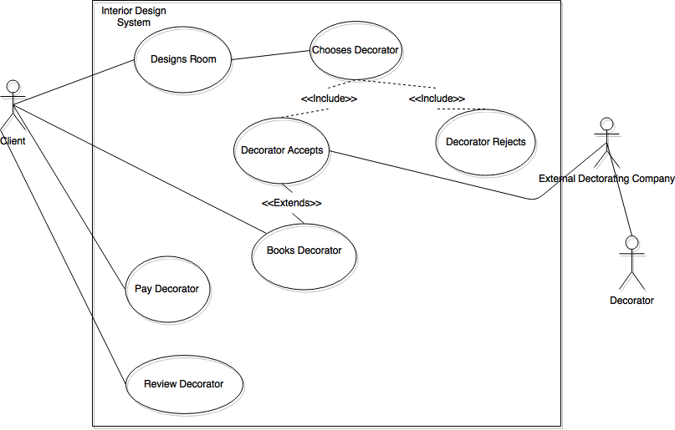

1. 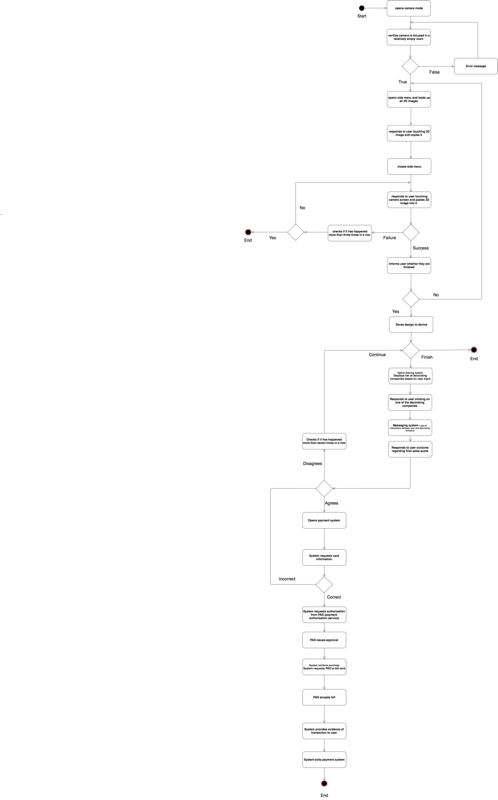Activity Diagram

L . Conceptual prototypes

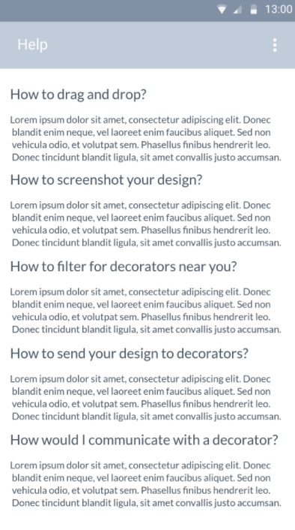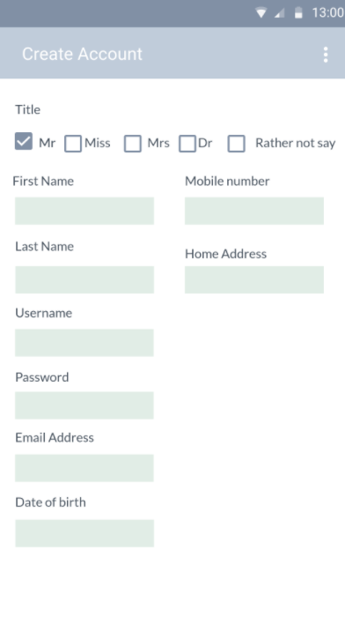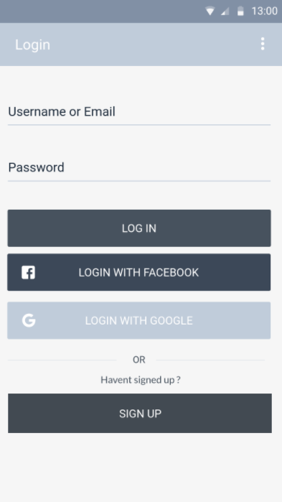 Login screen Create account Help-screen

Camera-screen

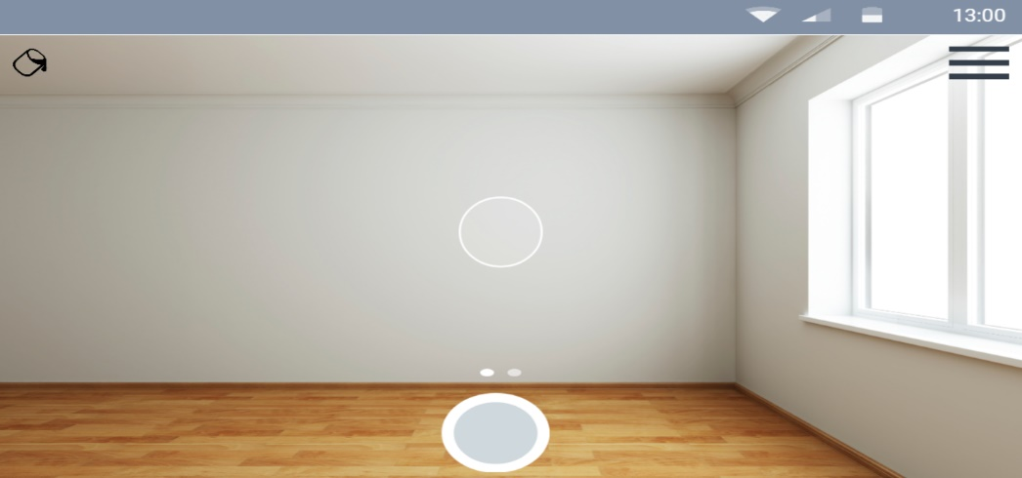

Camera-screen (furniture filter)

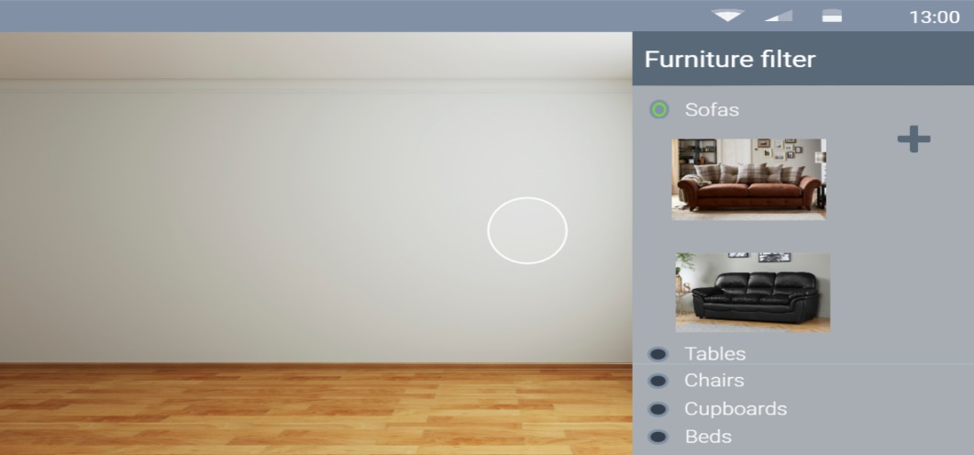

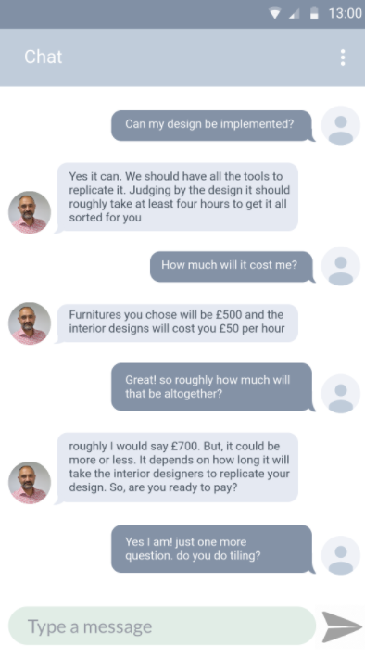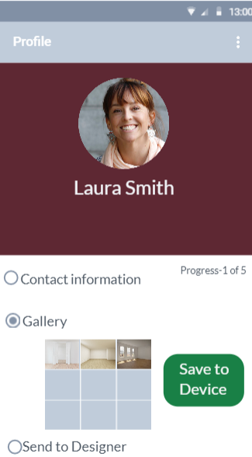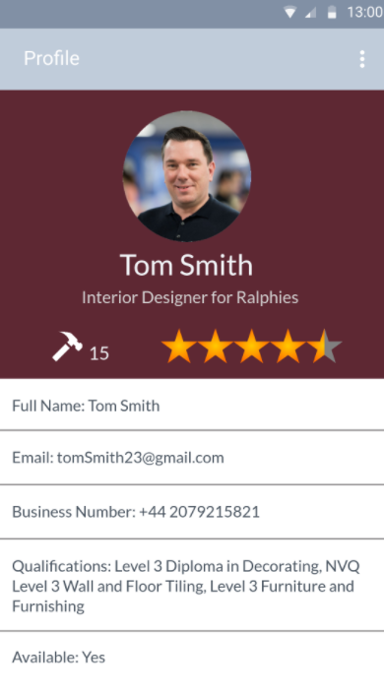 Decorator profile User profile Send design to decorator

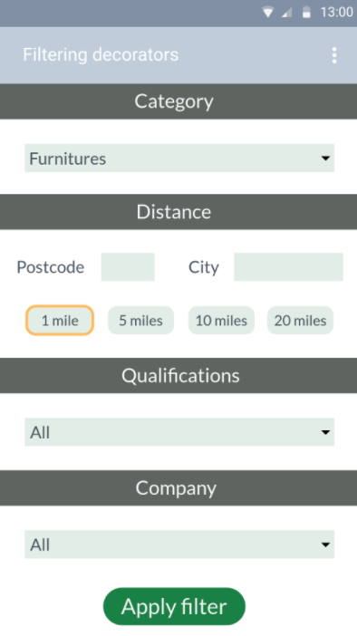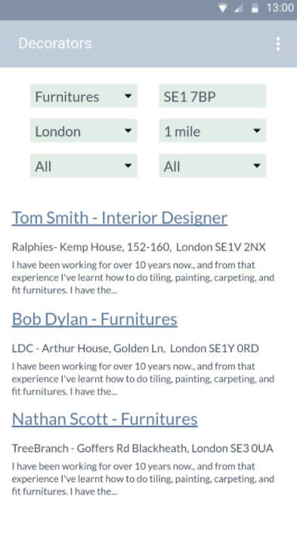Instant-messaging Filtering decorators Displaying decorators

Payment System

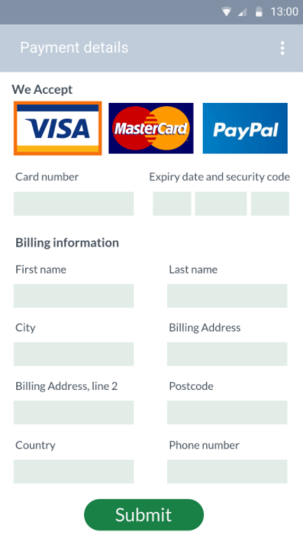

M. Conceptual prototype – survey results

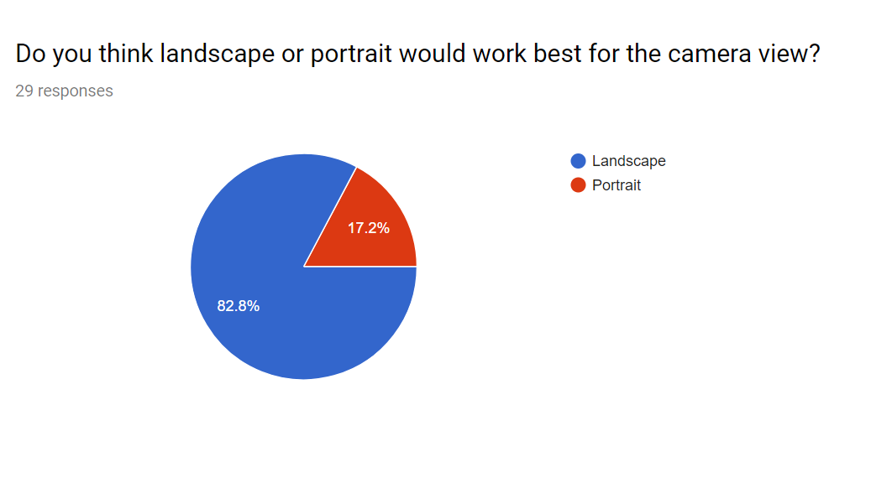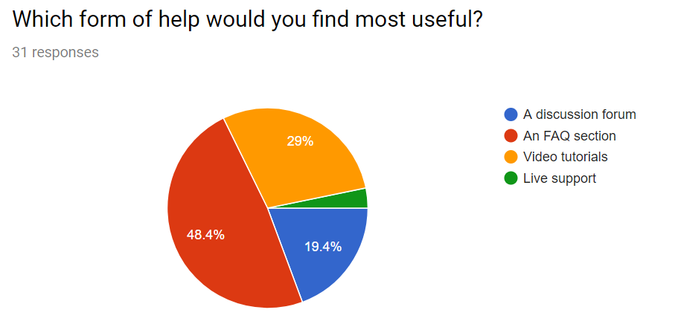Survey result 1 Survey result 2

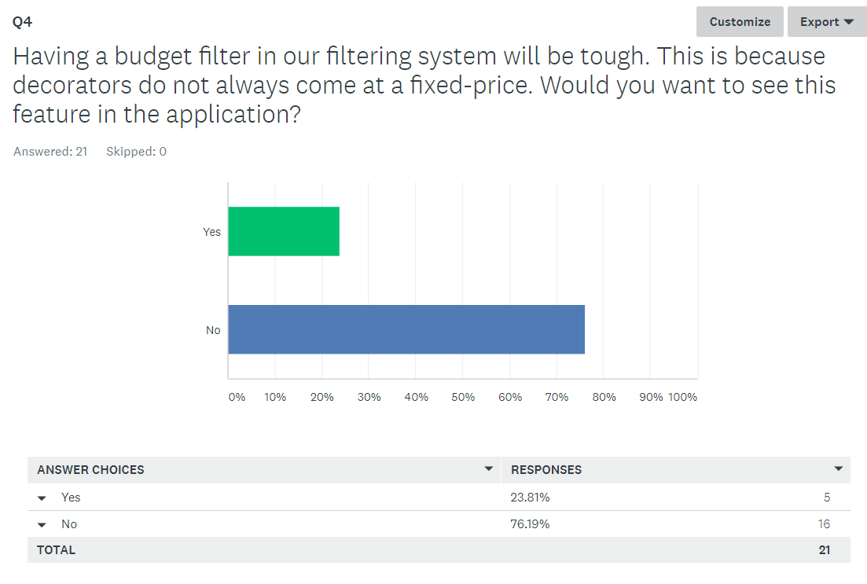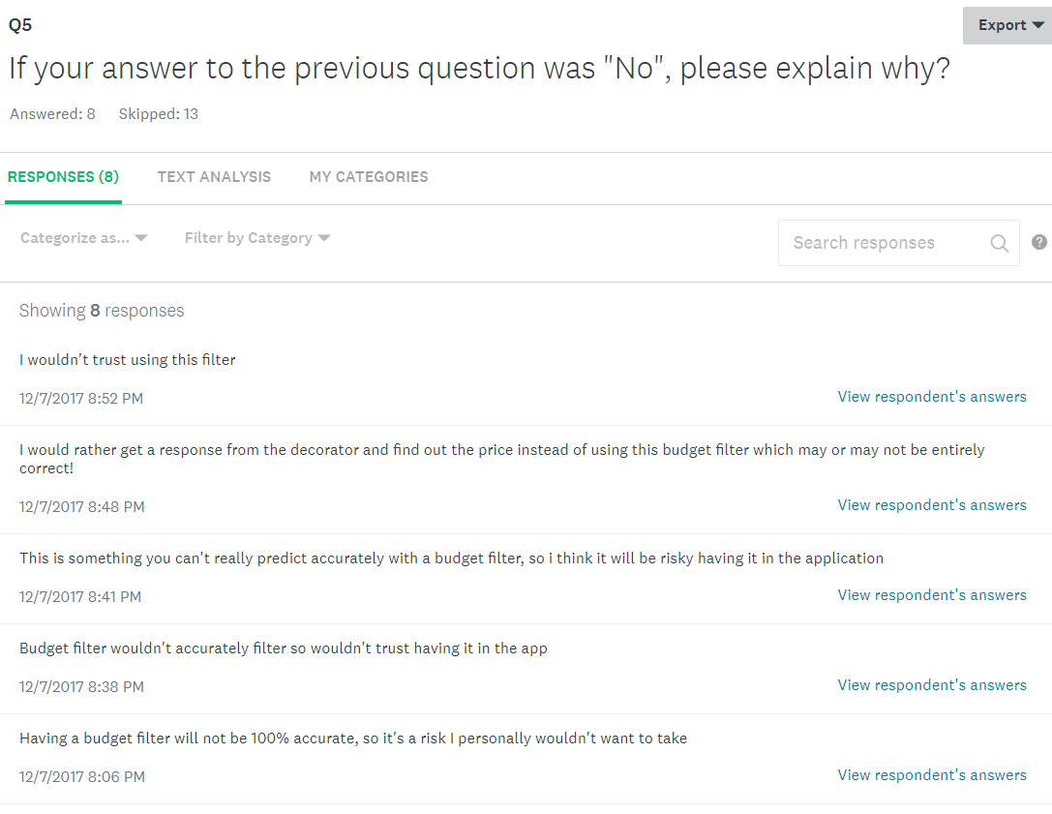Survey result 3 Survey result 4

Survey result 5

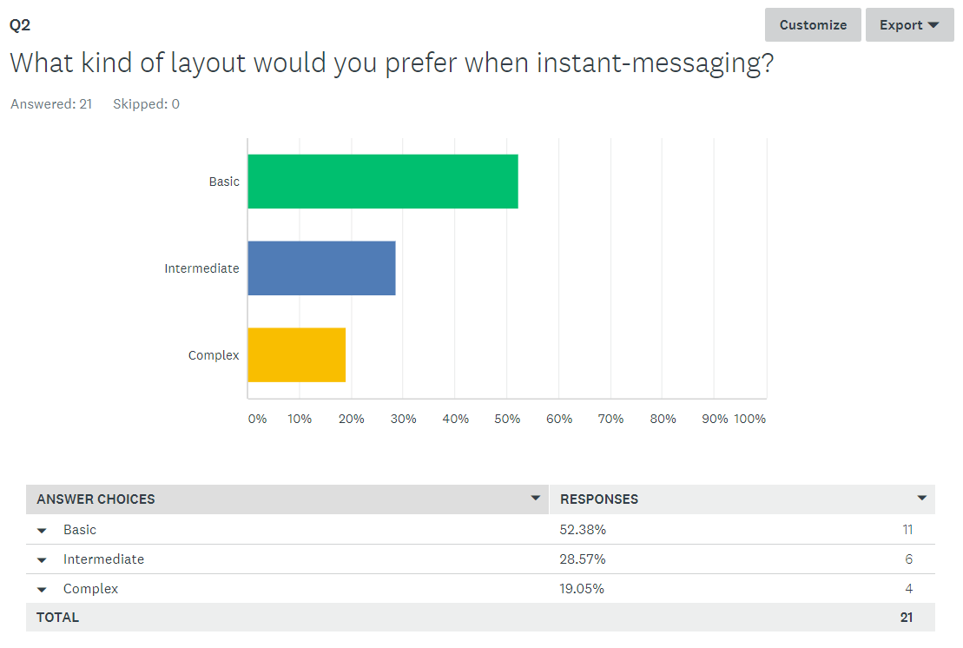

1. Statements of Interest?????

### Prototyping

2. Similar software researched

Dulux visualizer – an app distributed by Dulux which allows users to virtually test out their range of paint by applying it to their walls in an augmented reality environment.

The core functionality is strong; if we could manage similar results with some minor tweaks it would be ideal.

Drawbacks:

* Inability to paint connecting walls separate colours.
* No differentiation between ceiling and walls.
* Objects too similar in colour to the walls get misinterpreted as being part of the wall and change colour along with it.

Thoughts on their implementation:

* The software must utilise colour detection and then recolour anything within a certain “colour distance” to match the desired colour. This leads to both drawbacks, but allows for a very intuitive user-experience of simply tapping where you want to paint and it filling in the rest.
* While the errors in detection are frustrating, when working it manages to look very smooth. I believe it isn’t going through pixel by pixel and recolouring each one.

### Technical Architecture

1. USER CHART CLEON DID
2. SLAM research

Simultaneous Localisation and Mapping is the issue of mapping an unfamiliar area while simultaneously keeping track of the device’s location within that space. This technology is mostly in robotics, where approaches are applied in self-driving cars, planetary rovers or domestic robots [REF] . SLAM can also be applied in AR, as mapping and sensing unfamiliar spaces can aid object tracking and room virtualisation. The localisation will aid in the ability to walk around static 3D objects as their relative positions and rotations will alter as your perspective changes. SLAM varies a lot as it can involve several types of sensors and inputs but is commonly tailored to available resources.

### Project management

1. Gantt Chart

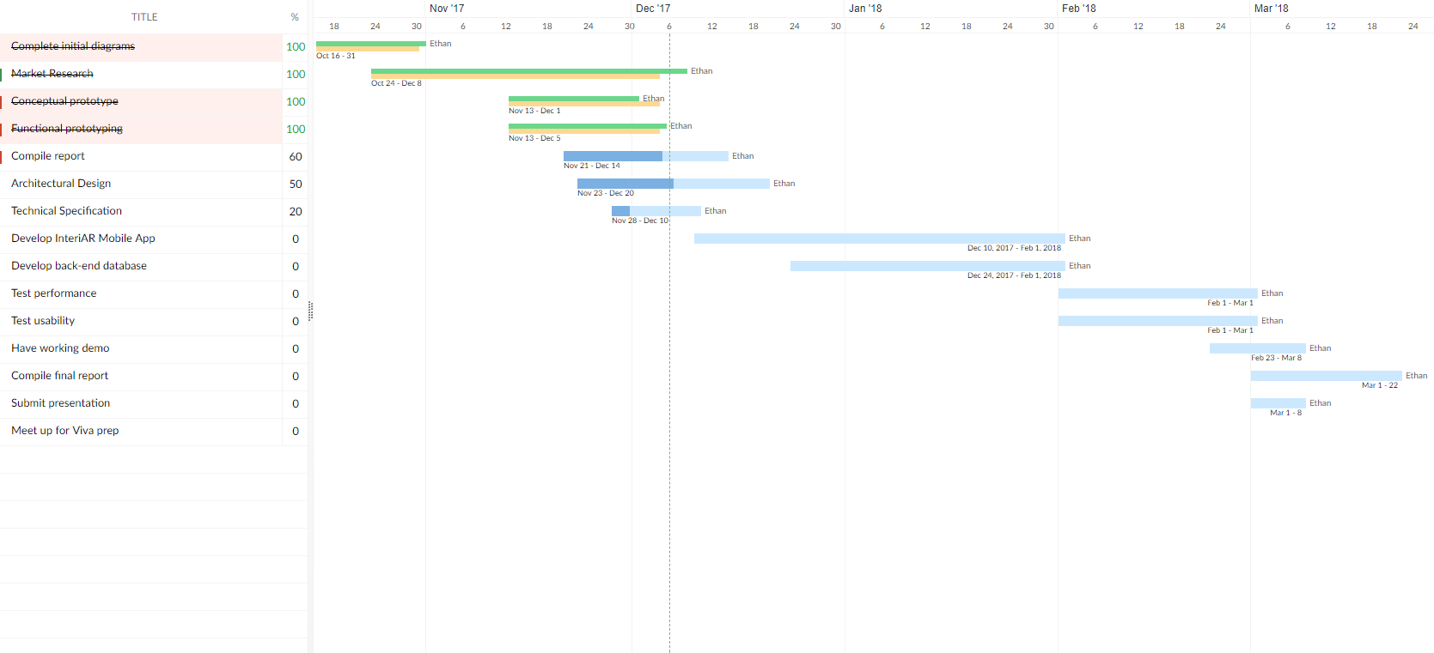

1. Critical Path

../Diagrams/Workbreakdown-CriticalPath/CriticalPathAddedTerm2.png

1. Work Breakdown

